Experiment 1: Case Study
Name: N Charitha Reddy
Roll No: 2420030425
Problem Statement: Choose a real-world case study of KL ERP System, create user stories, select an appropriate software development process model, identify a suitable programming language, and propose an implementation and evaluation strategy.

1. Functional Requirements
Student
The KL ERP system should allow students to:
- Login securely
- View and update their profile
- Register for academic courses
- View attendance records
- View course information
- View class timetables
- View CGPA and academic performance
- Access examination information
- Download hall tickets
- View fee payment details
- Access library services
- Participate in quizzes
- Submit feedback
- Access career and placement services
- View hostel and transportation details
- Raise support tickets
- Participate in clubs and activities
Faculty
The system should allow faculty members to:
- Login securely
- View assigned courses
- View student details
- Mark attendance
- Upload marks
- View student performance
- Upload learning materials
- Conduct quizzes
- Provide feedback
- Manage academic activities
Administrator
The administrator should be able to:
- Manage student records
- Manage faculty records
- Manage courses
- Manage attendance
- Manage examination details
- Manage fee information
- Manage timetables
- Manage hostel and transportation
- Manage support tickets
- Generate reports

2. User Stories

User ID | User Story | Priority
US-01 | As a student, I want to login securely so that I can access the KL ERP system. | High
US-02 | As a student, I want to register for courses so that I can attend my academic subjects. | High
US-03 | As a student, I want to view my attendance so that I can monitor my attendance percentage. | High
US-04 | As a student, I want to view my CGPA so that I can track my academic performance. | High
US-05 | As a student, I want to view my timetable so that I can attend classes on time. | High
US-06 | As a student, I want to view my examination and hall ticket details. | High
US-07 | As a student, I want to pay my fees online so that I can complete university payments. | High
US-08 | As a student, I want to submit feedback so that I can communicate my concerns. | Medium
US-09 | As a faculty member, I want to mark attendance so that student attendance is recorded. | High
US-10 | As a faculty member, I want to upload marks so that students can view their academic performance. | High
US-11 | As an administrator, I want to manage student and course information. | High

3. Selected Software Development Process Model
Agile Scrum
Reason for Selection
Agile Scrum is suitable for the KL ERP System because:
- The ERP contains many independent modules.
- Requirements may change based on university needs.
- New modules can be developed incrementally.
- Students, faculty, and administrators can provide continuous feedback.
- Bugs can be fixed quickly.
- Each module can be delivered through separate sprints.

Sprint Plan
Sprint | Features
Sprint 1 | Login, Profile and Role-Based Access
Sprint 2 | Academic Registration and Course Management
Sprint 3 | Attendance Register and Timetable
Sprint 4 | CGPA, Marks and Examination Section
Sprint 5 | Fee Payments, Library and Hall Ticket
Sprint 6 | Career Choice, CRT and Student Activities
Sprint 7 | Analytics Dashboard and Reports
Sprint 8 | Testing, Deployment and Evaluation

4. Programming Language Selection
Backend

Java – Spring Boot
Reasons:
- Secure
- Scalable
- Suitable for enterprise applications
- Supports REST APIs
- Provides excellent database connectivity
- Supports role-based authentication
Frontend
- HTML5
- CSS3
- JavaScript
- React.js
Database

MySQL
The database can store:
- Student details
- Course details
- Attendance
- Marks
- CGPA
- Fee payments
- Examination details
- ERP activity records
Data Analytics
- Python
- Pandas
- NumPy
- Matplotlib
- Seaborn
- Scikit-learn

5. System Architecture
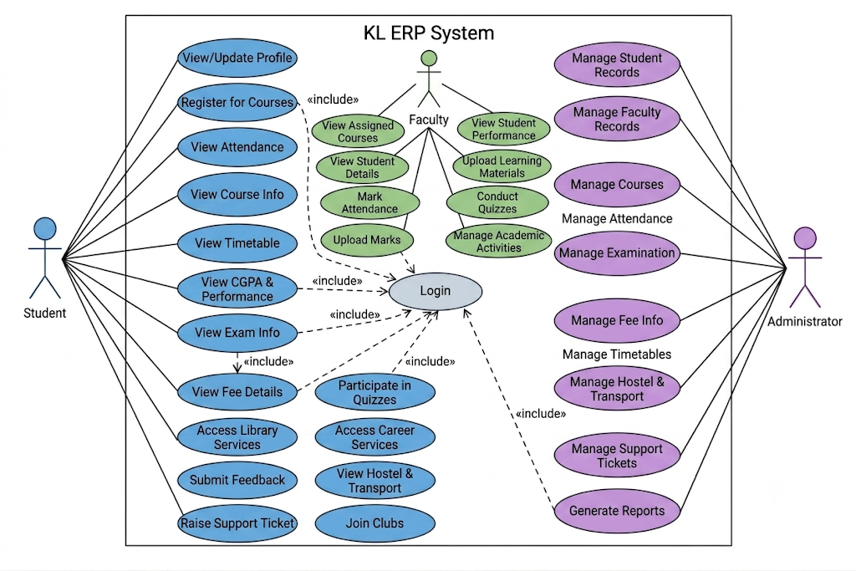

6. Implementation Strategy

Phase 1 – Requirement Analysis
- Study existing KL ERP modules.
- Identify requirements of students, faculty, administrators, and management.
- Prepare SRS.
- Create use case diagrams.
- Identify analytics requirements.

Phase 2 – System Design
- Design ERP database schema.
- Design analytics database.
- Design dashboard UI.
- Create UML diagrams.
- Design system architecture.
- Define data preprocessing workflow.

Phase 3 – Development

ERP Module Development
- Authentication
- Academic Registration
- Attendance Register
- Courses
- Examination Section
- Fee Payments
- Timetables
- Profile
- CGPA
- Feedback
- Career Choice

Analytics Development
- Collect the three benchmark datasets.
- Clean the datasets.
- Handle missing values.
- Perform exploratory data analysis.
- Identify important features.
- Create charts and dashboards.
- Apply machine learning models.
- Compare analytical results across the three datasets.

7. Evaluation Strategy
Evaluation Parameter | Method
Functional Accuracy | Requirement verification
Performance | Load testing using JMeter
Security | Authentication and security testing
Reliability | System monitoring
Usability | Student and faculty feedback
Scalability | Concurrent user testing
Maintainability | Code review
Data Quality | Missing-value and consistency analysis
Prediction Accuracy | Accuracy, Precision, Recall and F1-score
Analytics Performance | Comparison across three datasets
Dashboard Effectiveness | User evaluation

8. Expected Outcomes
• Centralized KL ERP management system.
• Easy access to academic and administrative services.
• Improved attendance monitoring.
• Better student performance analysis.
• Early identification of academically at-risk students.
• Data-driven decision-making for university management.
• Analysis of both traditional academic data and online learning behavior.
• Comparative evaluation using three famous benchmark datasets.
• Interactive analytics dashboards.
• Scalable architecture for future KL ERP enhancements.

